Schedule II-H-5.2
Page 36 of 37

PUC DOCKET NO.
ONCOR ELECTRIC DELIVERY COMPANY LLC
ADJUSTED WEATHER STATION DATA
FOR THE TEST YEAR ENDING DECEMBER 31, 2021

SPONSOR: D. E. NELSON

WEATHER SITE LOCATION & RESIDENTIAL CDD WEIGHT PERCENTAGES

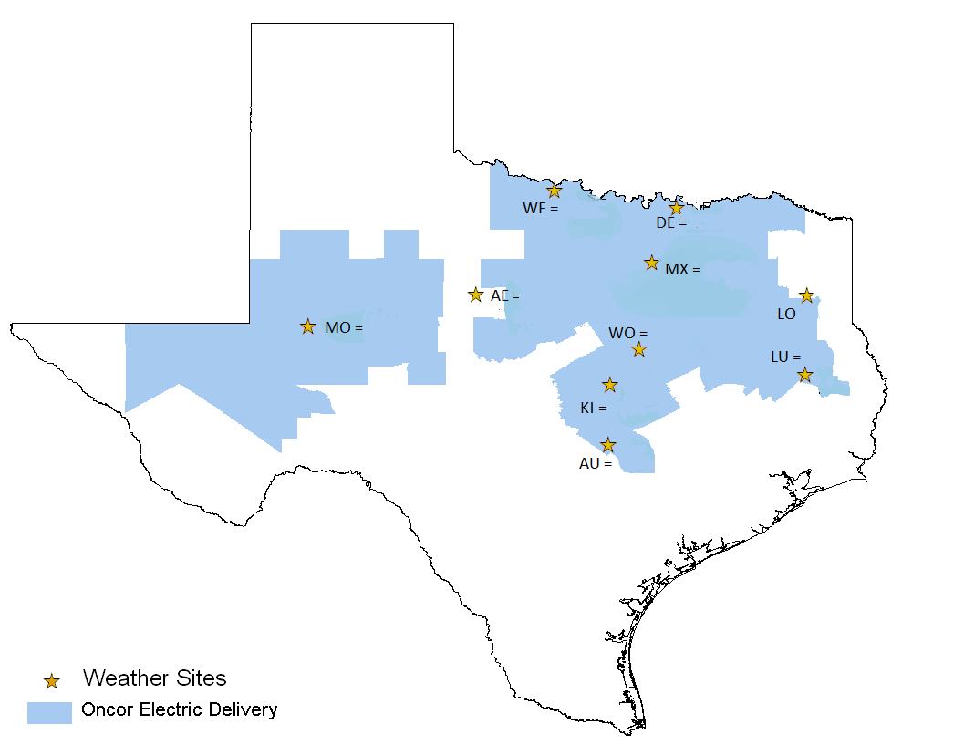
2.6%
= 3.5%
4.4%
4.5%
3.6%

70.5%

2.3%

1.9%
1.2%
5.6%

Schedule II-H-5.2
Page 37 of 37

PUC DOCKET NO.
ONCOR ELECTRIC DELIVERY COMPANY LLC
ADJUSTED WEATHER STATION DATA
FOR THE TEST YEAR ENDING DECEMBER 31, 2021

SPONSOR: D. E. NELSON

WEATHER SITE LOCATION & RESIDENTIAL HDD WEIGHT PERCENTAGES


1.4%
3.6%
5.1%
2.9%
= 3.8%
3.9%
68.9%%
2.7%
2.0%
5.7%

